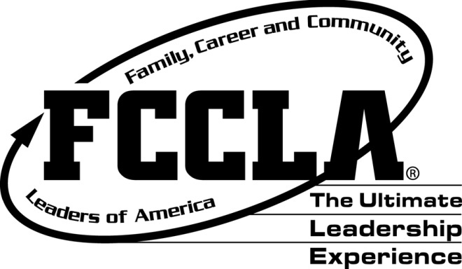

Overton
FCCLA Chapter
Handbook
2017-2018
Overton FCCLA Chapter

Dues:
National- $9.00
State- $4.00
District Dues- $4.00
Chapter- $3.00
Total: $20.00
Checks payable to: Overton Public Schools
***Please give ALL payments to MRs. EhLERS

Chapter Meetings- Mark your Calendars
Tuesday August 29th- Kick-off Meeting
Friday September 8th- Community movie night in the school gym- free to anyone
Popcorn and lemonade for a free will donation
Tuesday September 11th- short meeting at lunch, JH 1st lunch, HS 2nd lunch
Wednesday September 13th- Fall Leadership Workshop in Kearney
Thursday September 14th- PINK OUT at volleyball game
Thursday September 28th- FCCLA Concession Stand for volleyball
Friday September 29th- Decorate for Homecoming Dance after school
$100 deposit for FCCLA Cluster Trip to Oklahoma City must be paid. (*Only applies to those who CHOOSE to participate in this trip.)
Projects for this month:
Movie night, Pink Out, Concession Stand, Homecoming decorating

Tuesday October 17th- Chapter meeting
Wednesday October 18th- District Leadership Conference (DLC) at North Platte all members attend. Special dress code applies.
Projects ideas for this month:
Card games & Costume contest at meeting, begin work on STAR, DLC preparation
Tuesday November 13th- Chapter Meeting at 6:30 pm
Thursday November 16th- Teacher Appreciation Breakfast
Friday Nov. 17-Sunday Nov. 19- National Cluster Meeting in Oklahoma City
Project ideas for this month:
Financial Football, LIFE, Monopoly, STAR

Monday December 4th- Chapter Holiday Party at 6:30 pm in FCS room
December project- Secret Santa, family holiday donations, STAR

Saturday January 6th- Concession Stand basketball with Maxwell
Monday January 8th- Chapter Meeting at 6:30 pm
Monday January 22nd- STAR presentation night
Wednesday January 31st- District STAR at Mullen
Chapter Project idea:
Concession stand, cooking decorating, STAR

Monday February 5th - Chapter Meeting at 6:30 pm
Friday January 9th- Concession Stand
February 11-17th -National FCCLA Week
Monday February 26th- Peer Education Retreat in Kearney
Chapter Project this month:
Promote FCCLA Week, candy grams for Valentine’s Day, Valentine’s for nursing home residents

Tuesday March 5th- Chapter Meeting at 6:30 pm
Project this month:
Chapter scavenger hunt

April 8-10th- State Leadership Conference (SLC) in Lincoln
Monday April 16th- chapter meeting if necessary
Monday April 30- FCCLA Awards Banquet and Officer Installation
Chapter projects for April and May:
State, Banquet, community service and fundraisers as necessary
June 28th- July 2nd-National Leadership Meeting in Atlanta, GA.
**All meeting dates and times are subject to change. Please read the announcements for further details.
Additional fundraisers may take place during the year as well depending on chapter interests. If chapter members are interested in attending the National Cluster Meeting, we will try to fundraise for this event.

All members are expected to participate in major chapter fundraisers- concession stands, food suppers during games, etc. The proceeds will then go towards paying for those members who chose to attend additional conference and competitions as well as provide meals, games, etc. for all chapter members at chapter meetings and projects.

DRESS CODE- ALL students attending FLW, DLC, Peer Education Retreat, State and/or National conference must abide by the state and national dress code. Red, white, or black polos, black or khaki dress pants and closed toe black shoes are always appropriate attire. Your polo does not need to say FCCLA on it. FCCLA polos may be purchased from the national website or by talking to Mrs. Ehlers for around $13. You can also purchase plain polos from JC Penny, Walmart, etc. for usually $10 or less.
*Students wishing to attend District Leadership Conference in North Platte in October may also purchase a district t-shirt. If they purchase this t-shirt they may wear jeans to the meeting that day. T-shirts will cost around $10-15. If students do not purchase a t-shirt they will be expected to follow the official state and national FCCLA dress code.

STAR- Students Taking Action with Recognition
District competition in January at Mullen---State Competition is in April in Lincoln at SLC. Projects must be started no later than middle of October. There will be STAR work nights after school in October, November, December and January to work on projects. There are over 20 categories to enter- you can do an informational speech on a topic that relates to FCS and FCCLA or a project on a variety of issues. If you are interested see Mrs. Ehlers ASAP to get started!

Getting Credit for being a member of FCCLA
To receive credit for FCCLA you must:
- Pay your dues ($20.00)
- Attend DLC and/or participate in STAR
- Attend at least 5 chapter meetings
- Participate in at least 5 chapter activities

Awards & Recognition
- Each member will be recognized on their birthdays or half-birthdays by FCCLA.
- Members who compete in STAR or who complete other projects such as Power of One, or service projects will be recognized on the school’s web page, school newsletter, school announcements and possibly local newspapers.
- At the end of each school year all members who earn their credits for being a member will receive a certificate of membership as well as a gift from the chapter. Gifts will be based on years of membership.
- STAR participants that earn a trip to the State STAR competition will receive a STAR chenille letter pin to signify “lettering” in FCCLA.
- Power of One Participants will also receive a special chenille letter pin to signify “lettering” in FCCLA and will be eligible to attend the state leadership conference.
- FCCLA will also recognize any adult volunteers who go out of their way to volunteer their time to help our FCCLA chapter with activities and events.

